31.28: a) The amplitude of the current is given by
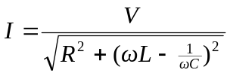
Thus, the current will have a maximum amplitude when
b) With the capacitance calculated above we find that 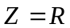, and the amplitude of the current is 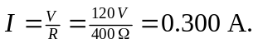Thus, the amplitude of the voltage across the inductor is

